Digital ‘Synth Design’ Assignment

*Digital Synthesizer*  
*Jumpstart- ‘hackathon’ project  
Kick off Assignment*  
  
  
Semester 7  
SnES, Class 1,  
Fontys HBO-ICT

|  |  |  |
| --- | --- | --- |
| *Authors* | *Date* | *Revision* |
| Andrija Hanga | 21/02/2024 | Draft |
| Valentin Stoyanov | 23/02/2024 | Draft |
|  | 24/02/2024 | Final Version |

Table of Contents

Introduction 3

Task and Requirements 4

Idea 5

Development Stack 6

Process of Development 8

What’s Next? 11

Conclusion 12

# Introduction

In exciting world of Signals and Embedded Systems (SnES) in this Minor, this will be the first challenge.   
As a group of 2, Valentin Stoyanov and myself will need to create digital synthesizer device. By starting off with an idea to generating a concept all the way to building synth that generates audio and interacts with outside world.   
  
This assignment gives an exciting opportunity to get to know signals, understand their nature, how they traverse, what they are and most importantly actively work with them. In this case focus will be on audio signals, providing a hands-on experience that dives into signal processing.

# Task and Requirements

Task

* Create Synth Design
* Make use of Electrical components provided
* Document progress

Requirements

* 4 days
* Teensy 4.1 Microcontroller
* Teensy Audio Shield
* Working with audio signals

# Idea

For this project our idea is to create a digital synthesizer using Teensy 4.1 microcontroller.

We want to have synth that receives an audio signal using Audio Shield, using potentiometer adjust the frequency and pass it to the next step. Where next step would be to play samples in different pitches, using that frequency which is in between 10Hz – 16000Hz. Using buttons, we would like to be able to play different tones, keys.   
  
On top of that our goal is to also add another potentiometer, this time around for generating envelope. Knowing that envelop has different stages: attack, decay, sustain, and release (ADSR). We would need for knob to cover mentioned. It enables us to adjust the tone so it’s played with different duration.  
  
Adding another knob, potentiometer, will be used for volume control. Since, we think that is something necessary on every synthesizer. Also, speaking of necessary things, we made sure to add ON/ OFF (Mute/ Unmute) button, another necessity.

We realized that we want to process signal even further, which led us to adding 4 possibilities for changing the waveform. Knowing that we added 4 different waveforms that impact our signal. In this case those were: Sine, Square, Sawtooth and Triangle.

We would like to reach goal of creating a fully functional synthesizer. Of course, not having all functionalities, just core ones mentioned above. With which we think synth cannot work without or at least would not sound the same.   
At the end, coming to the part where we want to add melody, tone to the signal that we are sending. Adding keys to synth will allow us to produce different sounds, as well as many combinations. In general, we would not be able to fit the whole keyboard, however only few keys that will allow us to produce sounds. On the other side, that sounds can modified using one or more functionalities from above and eventually create even more unique sounds.

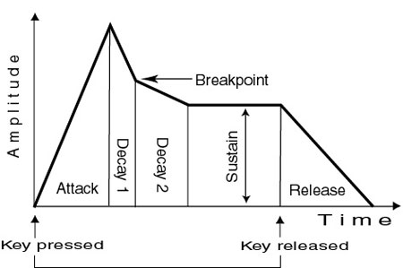  
Figure 1  
ADSR Envelope, Amplitude over Time

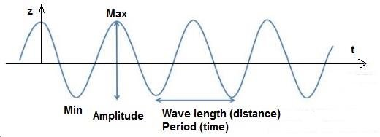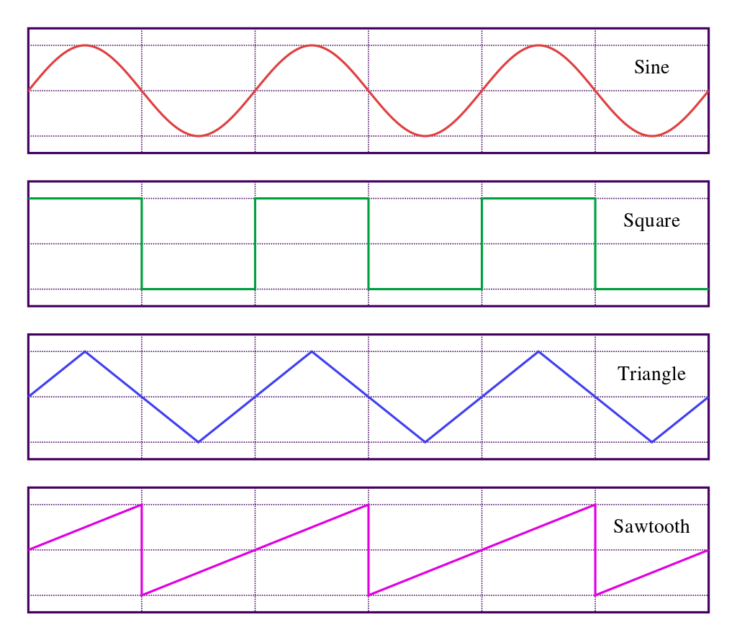

Figure 2  
Regular Signal

# Development Stack

Figure 3  
Sine, Square, Triangle and Sawtooth signal waveform

For this project we used:

* Teensy 4.1 Microcontroller
* Teensy Audio Shield
* 2x Bread Board
* 6x Potentiometer
* 1x Bigger push button
* 8x Smaller push button
* Jumper cables

# Process of Development

In this part, we will explain how the process of development went. We will use pictures to represent the phases of growth of the project. What were the difficulties and challenges we faced and solved.

At the beginning, Valentin and I talked about what needed to be done. We talked about what we wanted to develop and product we want to deliver. We got the perfect chance to work with audio signals and got us thinking how to process the digital signal.  
  
In order to understand the assignment as best as possible, we researched what synthesizers are, what DCP (Digital Signal Processing) is. Finding out that production of digital ones started 1980s.In 1982 MIDI (Musical Instrument Digital Interface) was introduced. MIDI still stands as industry standard and is used for audio production.   
Other than that, it gave us an idea of what we want to create, we started off by connecting potentiometer and playing with FM (Frequency Modulation) of the signal we were getting from the Audio Shield.  


Figure 4  
Digital signal being processed

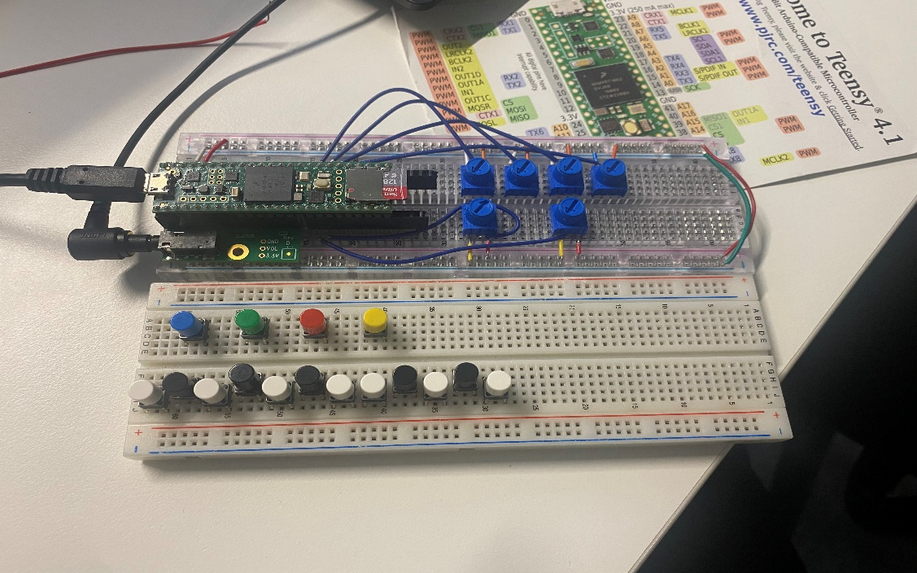  
After being able to get the signal and work with it, we realized that we would like to be able to adjust it even further. We divided the work.   
Valentin took the part of setting up: Volume, FM, ADSR for Envelope and ON/ OFF button.   
While on the other side, I worked on setting up: Musical keyboard and Buttons for 4 different waveforms (Sine, Square, Sawtooth and Triangle).  
  
Eventually, connecting our work, in this case breadboards, resulted into having technological parts to look alike synthesizer.

Figure 5  
Digital Synthesizer, draft

Following the process, we started to connect everything and wiring pieces to work simultaneously.  
In our next goal, after connecting the breadboards, we wanted to be able to produce different tones and that is when we started working on the keyboard, keys of the synthesizer. Our idea was to have the full keyboard, however due to limited number of digital pins we were not able to fit all the keys. So, instead of having multiple keys without any specific order we agreed to limit our selection. We decided to go with some of the basic notes, in this case: note C, C#, D, D#, E.

This is how one of our latest versions looked like, after updating the keyboard on the synth.

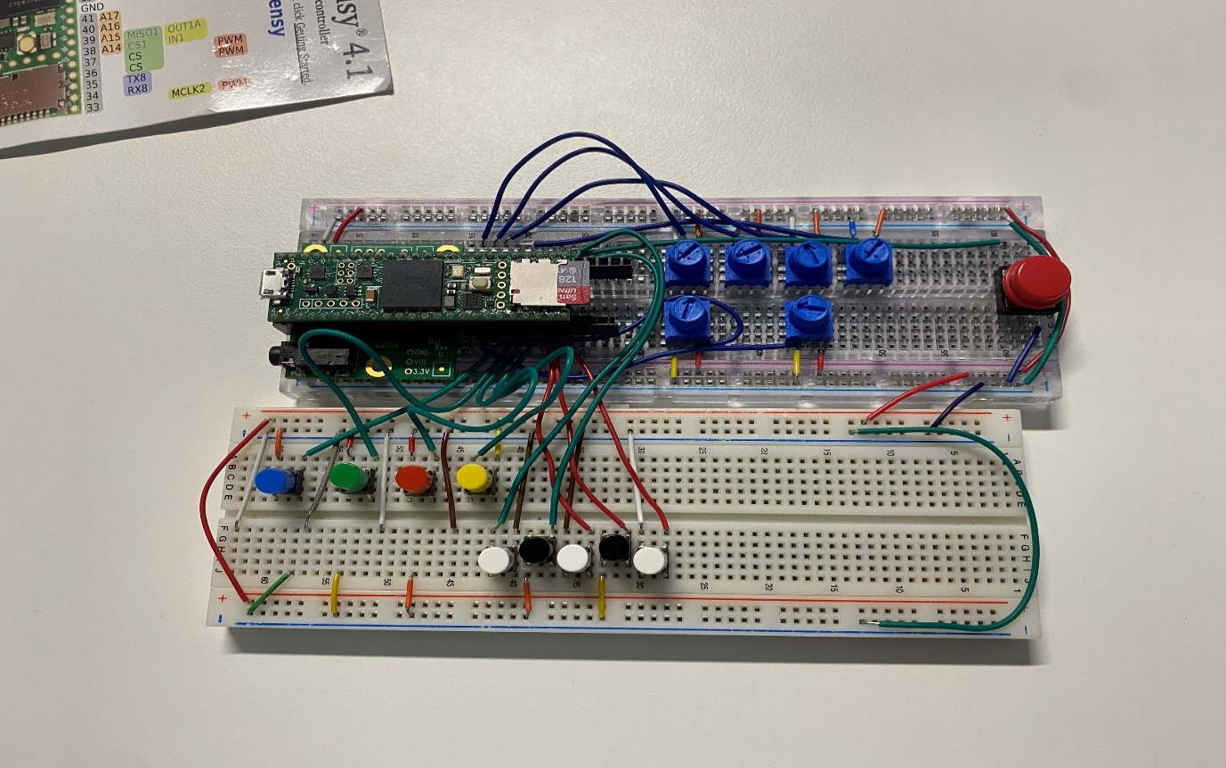Figure 6  
Digital Synth, with parts connected to the Teensy 4.1

After some discussion with the teacher and in the last steps. Valentin and I managed to utilize the idea and see how we want to finalize the project. We decided to leave out FM, knowing that each tone produces different frequency, so we decided to replace it and introduce LFO (Low-frequency oscillator). Since, only we knew the organization of the synthesizer we needed to think about the way to display the organization of components to others. We realized that we don’t have many space left, and that including LED’s could cause confusion. So, we decided to keep it simple yet effective. Adding a small piece of paper where legend and the topic of the project is explained was our solution.   
  
Here you can see how final version of the project looks like.

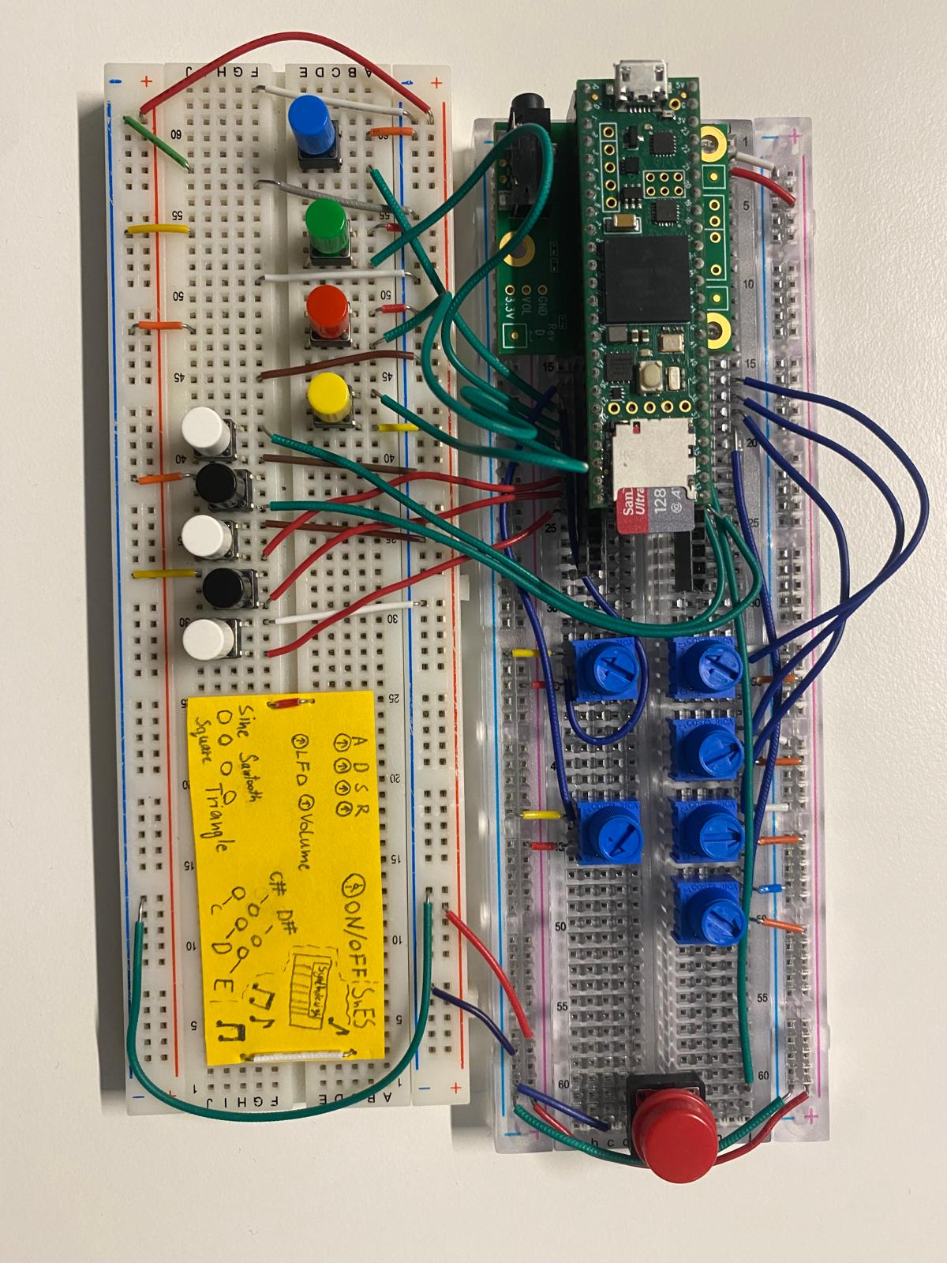

Figure 7  
Completely operational digital synthesizer

# What’s Next?

Knowing that synthesizer is an instrument that allows unlimited options, it was difficult to chose which one suits this project the best. We decided to go with core ones in our opinion.  
  
However, being mindful that a musician would have different preferences or requests.   
  
In this case, to address this and improve the solution, we think that adding the whole keyboard would be a must.   
Besides that, including things like: VCO, Source mixer, VCF, Bender and glide would improve the synthesizer overall and it is something we see as our next targets.   
  
Considering the time limit, achieving a functional digital synth is something we are happy about and enjoyed working on while staying open to the future upgrades.

# Conclusion

In conclusion, we really enjoyed working on this project. This was a perfect opportunity to get to know signals and various technical aspects of the project. Go in depth with audio signal processing, audio engineering and everything in between.   
We also managed to learn significant information, both about and from one another. Working with each other felt incredibly collaborative and inspiring. Making the entire process enjoyable and productive.